**Our Energy Future**

**Biological Energy Options**

*Biofuels:* Renewable sources of fuel that derives from *recently* living organisms or their metabolic organisms.

The reason why the word *recently* is emphasized is because fossil fuels derived from living organisms whose biomass was transformed by geologic forces over millennia. Contrast that with biofuels which derive from organisms that were living in the recent past.

Biofuels have been used by humans for millennia in the form of burned wood, charcoal or dung. The more modern types of biofuels include:

* Bioalcohols (e.g., corn)
* Biodiesel (e.g., vegetable or cooking oils)
* Biochar (waste products from agriculture that can be burned to produce electricity
* Biogas - products derived from the anaerobic digestion/decomposition of organic material (e.g., methane from a cow or within a large bioreactor)

The reason why biofuels are important is because they derived from plants and algae which have converted sunlight energy into chemical energy that is stored for use when we need it. The biomass that are most useful in producing biofuels are those that are rich in carbon-carbon and carbon-hydrogen bonds; petroleum, coal, wood, and charcoal are some materials that have these kinds of bonds.

Because CO2 is so plentiful in the atmosphere, a goal of biofuels is to combine with hydrogen to make these carbon-carbon or carbon-hydrogen bonds which can be used for fuel. This combination of hydrogen with CO2 is not something that will happen readily – there isn’t enough energy in the inputs as there is in the output we want to get out of the conversion.

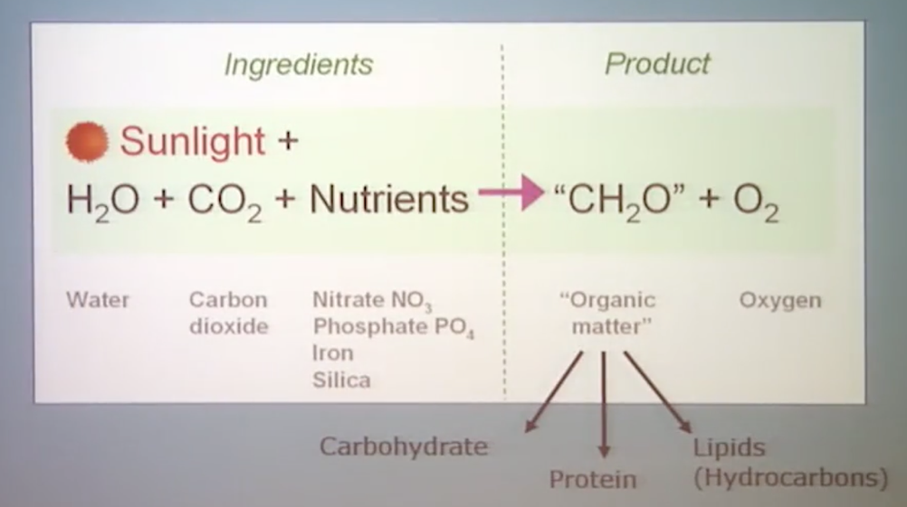However, plants/algae *do* perform this process in a way that produces organic matter which we can use for fuels, specifically in the form of carbohydrates, proteins, and/or lipids/hydrocarbons

*Plants/Algae, Photosynthesis and Biofuels*

The reason why humans can’t naturally convert energy from sunlight is because we can’t create a chemical reaction occur when we interact with that sunlight energy.

Plants, on the other hand, can take carbon dioxide from the atmosphere along with energy from the sun to undergo a chemical reaction in which plants store chemical energy in the form of sugars through the use of a *chloroplast* where photosynthesis occurs.

Within the chloroplast, two chemical reactions simultaneously occur. First (in a process known as *chemiostasis*), the chloroplast absorbs light and combines that with the water stored within a plant to boost and store the electrons from the water to a higher energy level as well as producing an organic compound called adenosine triphosphate (ATP). Second (in a process known as the *Calvin cycle*), the carbon atoms from CO2 combine with these high energy electrons and ATP to form glucose molecules within the plant that can be combusted to release this stored energy and provide power to all of our modern accessories.

When plants and algae carry out photosynthesis, the result can be converted into biofuels. Some of the most common byproducts of photosynthesis that are used for biofuels include:

* Triglycerides and fatty acids
* Cellulose: Polymer of sugars
* Hydrocarbons and isoprenoids
* Carbohydrates: sugars and starches
* Biomass
* Hydrogen

*First Generation Liquid Biofuels – Ethanol and Biodiesel*

There are two types of biofuels that have been around for a number of years – *ethanol* and *biodiesel*.

In the case of ethanol, we take plant material that is rich in sugar and use that sugar to feed microorganisms which become fermented into ethanol. The most common sources of ethanol are from corn and sugar cane, although any type of starchy crops (e.g., potatoes) can be used.

The process for creating ethanol has been around a long time, with Brazil and the US being the leaders in its production; Brazil using mainly sugarcane and the US using mainly corn. In 2012, 40% of the corn grown in the USA went toward ethanol production. One limitation of ethanol specifically is that we need to blend it with traditional gasolines in order to power our machines, since engines cannot run on pure ethanol.

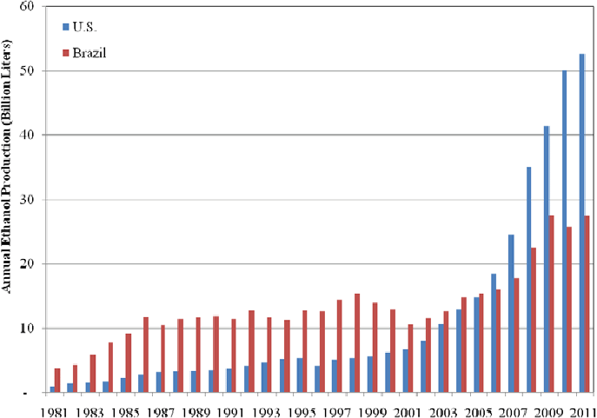

For biodiesel, we take fats within sources like vegetable oils or animal fat and undergo the process of *transesterification* which release fatty acid methyl esters which are then useful as biodiesel. Unlike ethanol, biodiesel can go directly into engines to power its machinery. Additionally, the energy density of biodiesel is greater than ethanol which means the same amount of biodiesel can provide more power to machinery than can ethanol.

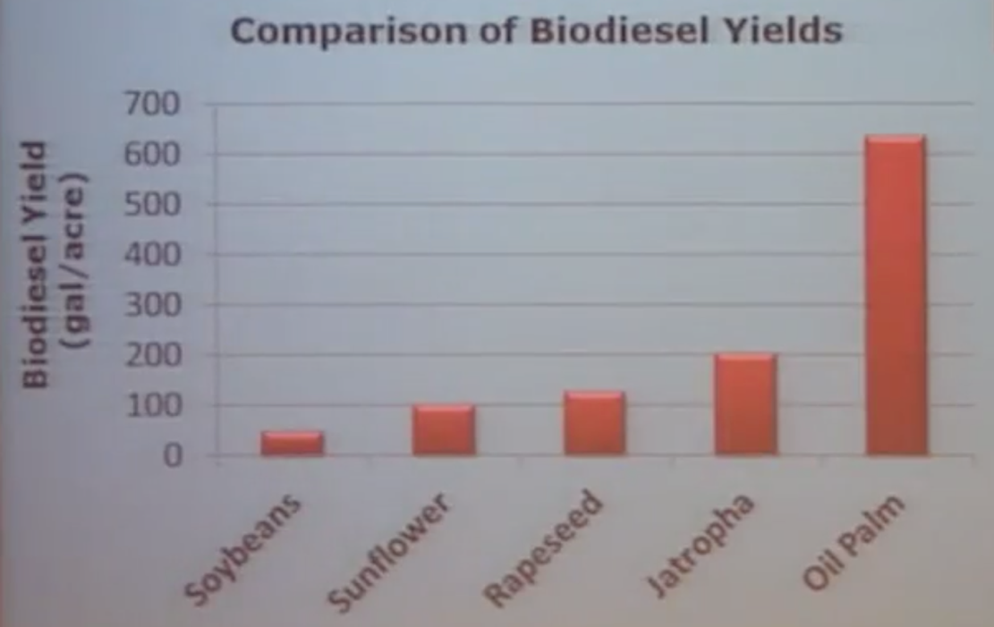

Biodiesel is created as a byproduct of food crops. By far, the crop yielding the most amount of biodiesel per hectare of land is the oil palm plant.

The oil palm is a perennial tropical plant grown in warm climates, produce fruits after 30-36 months and are economically viable as a crop (for either food or fuel) for 25 years. The fruits contain two parts – the *kernel* and the *mesocarp* – each producing a different kind of oil that can be used for both food and fuel.

An issue with the oil palm is that the growth range is a very narrow range around the equator – in the northern parts of South America, in central Africa, and southeast Asia. Additionally, these are derived from crops which are also used as food, and therefore growing crops to produce fuels takes the land/water which are needed to produce the biofuels out of the supply to produce food.

To overcome this challenge, more attention has been paid to *jatropha* as a possible replacement/complement to oil palm. Jatropha is a plant that has a few important characteristics for biodiesel – it produces seed that yield oil, it can survive two years without water, it is an undomesticated crop, it is not a food source and can be grown on marginal land. On the other hand, it does not yield as much biodiesel as does oil palm. However, jatropha is *undomesticated*; its seeds have not yet been bred to produce the strain that is most useful to humans. So the yield referenced above might increase as humans understand the different varieties of jatropha and their respective properties.

*Algae*

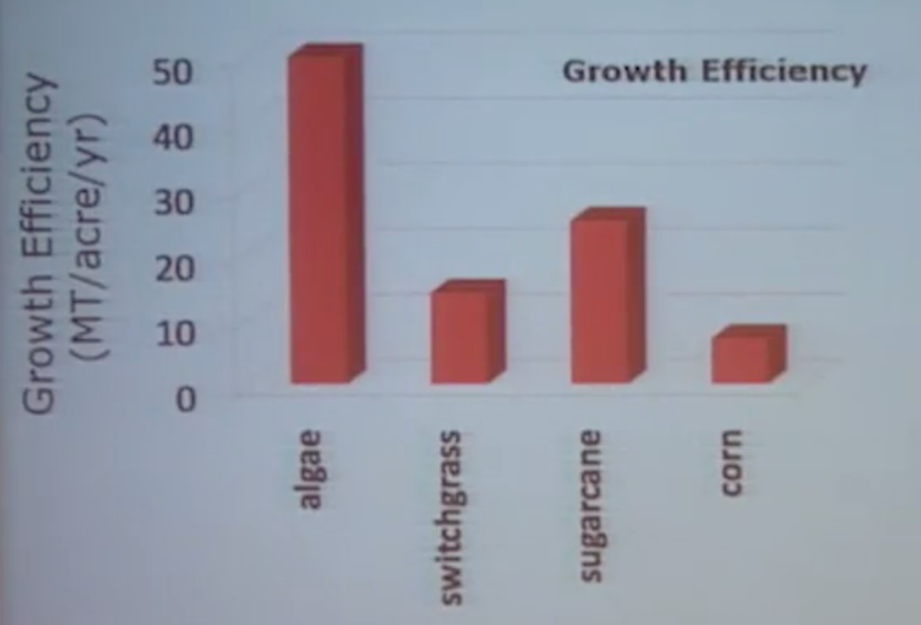Algae can be grown to produce biofuels as opposed to ethanol, meaning that it can go straight into engines without combining with petroleum beforehand. There are already products, albeit on a smaller scale, that have algae and other *cyanobacteria* (bacteria that gets their energy through photosynthesis) included – kombucha, hair/beauty products, sushi, etc.

One of the reasons why there is so much interest in algae as a source for biofuels is that algae grows faster and uses sunlight more efficiently than do other, land-based sources of biofuels.

In addition to the growth rate displayed above, algae has 3-9% solar energy conversion efficiency, compared to the 2.4% for C3 (crops that produce compounds that have 3 carbon atoms during photosynthesis) and 3.7% for C4 crops (crops that produce compounds that have 3 carbon atoms during photosynthesis); the majority of crops produced are C3 crops.

A few other notes about using algae as a biofuel:

* Algae has an overall 6-12x increased energy yield from the sun over terrestrial plants
* Algae can grow over a greater range of light environments in terms of intensities and wavelengths
* Productivity is less efficient in open pond systems compared to closed photobioreactors. Optimizing ecological conditions may improve these growth efficiencies.

|  |  |  |
| --- | --- | --- |
| **Source** | **Oil Content (%)** | **Oil Yield (gal/acre)** |
| Algae | 20-60 | ~5,000 |
| Canola | 40-45 | 113 |
| Jatropha | 32-35 | 202 |
| Mustard | 25-27 | 70 |
| Palm | 48-52 | 635 |
| Safflower | 42-48 | 146 |
| Soy | 20-22 | 55 |

Another advantage of algae is the oil yield per acre of “harvestable” area (whether that harvestable area is land or water depends on the specific source).

The main issue is scaling up to create the environments which produce the algae.

*Scaling Algae production systems*

There are two main ways to produce algae on an industrial scale – *open ponds* and *photobioreactors*.

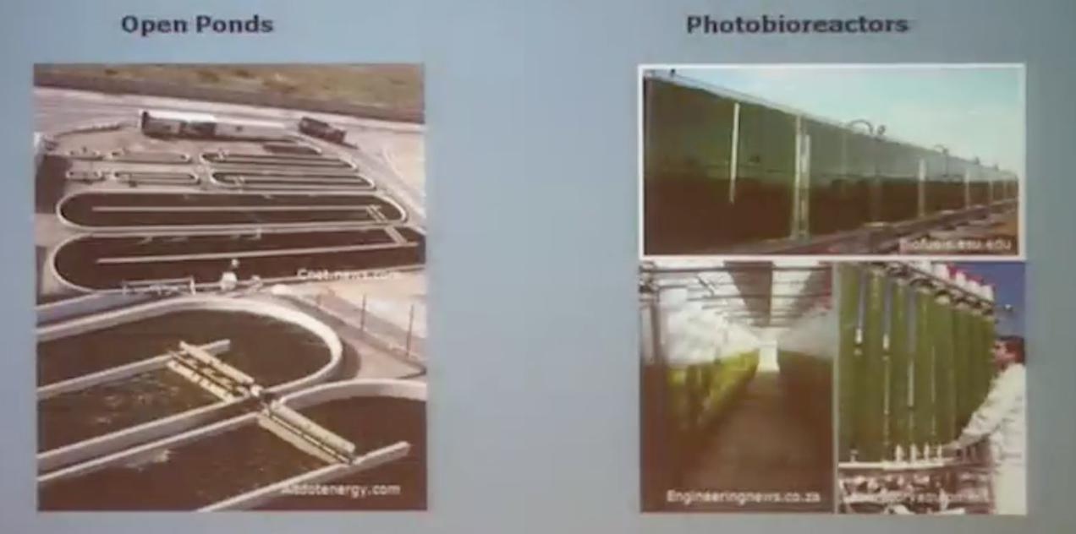

* Open Ponds

Benefits of open ponds include lower energy input needed as well as a lower price to maintain.

Challenges include the possibility of contamination as they are open to the air and to predators/grazers that would infect the ponds, and low cell density meaning less productivity in the output

* Photobioreactors

Benefits and challenges for photobioreactors are essentially the opposite of open ponds. Benefits include limited possibility of contamination, complete environmental control so no possibility of grazers/predators infecting the supply, and higher productivity in comparison to ponds.

Challenges are that there requires higher amounts of energy to run the photobioreactors, and higher prices of the algae biofuels that are produced.

*Types of Algae*

There are two different kinds of algae – *microalgae* (or microscopic algae) and *macroalgae* (algae you can see with the naked eye) – both of which are being developed for biofuels. Macroalgae includes things like seaweed, and while it is being used to produce sugars for fermentation which then is used as biogas or ethanol, microalgae is the more common algae which is used for biofuels.

Microalgae are miniature biochemical organisms that have the same type of photosynthesis as plants have. Some common types of microalgae are cyanobacteria, diatoms, red algae and green algae. While all of these types of algae are used for biofuels, each of these four types of algae are very genetically different from one another. Cyanobacteria are more related to bacteria like ecoli while diatoms, red algae and green algae are more similar to plants, from a genetic perspective.

Diatoms have been the center of much attention within the biofuel industry mainly because they are very good at making neutral lipids or fats which can produce biodiesel very easily through a transesterification reaction.

Cyanobacteria grow in a number of diverse environments and have a few attractive qualities when it comes to producing biofuels – it can *fix* nitrogen from the air (meaning it can take inorganic nitrogen molecules from the air and affix that molecule to an organic compound.

*Challenges with algae-based biofuels*

There are a few challenges that remain when thinking about incorporating a larger amount of biofuels into the energy mix:

* Scaling production of algae to be used as input
* Food and feed are economically viable before algae is
* Economic viability of the fuel products created from algae (carbon tax may be essential for algae-based biofuels to compete)
* Economic sustainability – how to ensure algae-based biofuels are economically viable without subsidies